TEAM NAME | Project MEKA
UNIVERSITY | Nebula Institute of Technology
PRODUCT NAME | Project MEKA
CATEGORY | AI / IoT / Personal Assistant
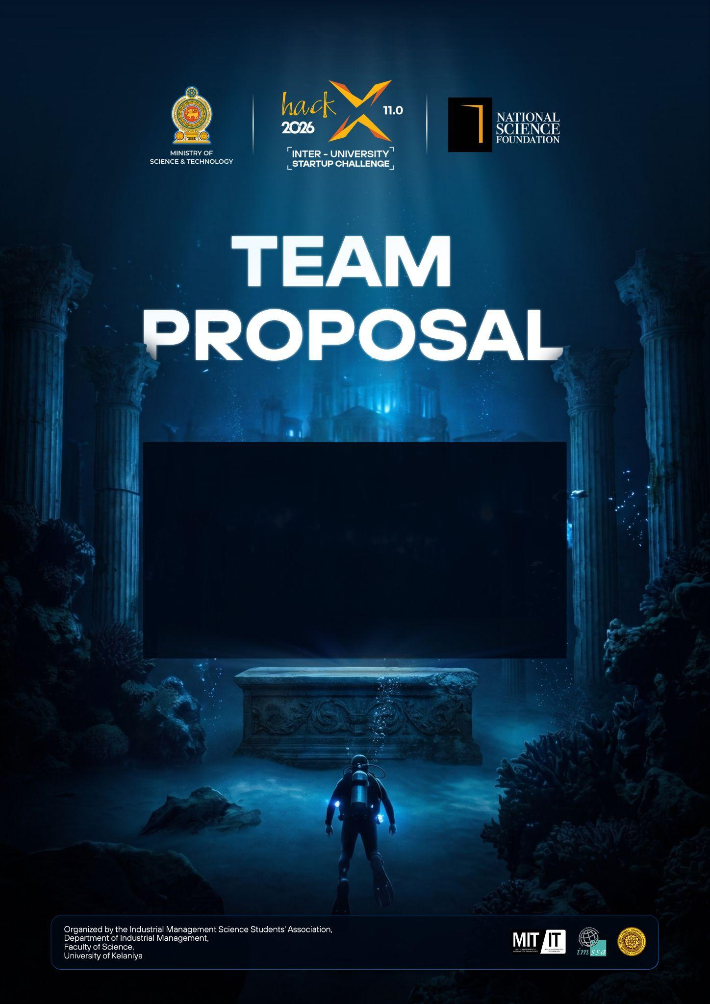

Table of Contents
Table of Contents 1
1. Executive Summary 2
2. Problem Definition & Solution 3
2.1 Problem Definition 3
2.2 Problem Analysis 3
2.3 Proposed Solution 3
3. Product Overview 4
3.1 Product Overview 4
3.2 In-Scope & Out-of-Scope 4
3.3 Uniqueness & Special Features 4
4. Market Analysis & Business Strategy 5
4.1 Target Audience & Market Opportunity 5
4.2 Competitor Analysis 5
4.3 Initial Go-to-Market Strategy 5
5. Business Model & Growth Plan 6
5.1 Business Model Canvas 6
5.2 Partnerships & Funding Strategy 6
6. Technical Overview & Implementation 7
6.1 Technical Overview 7
6.2 Implementation Plan 7
7. User Experience & Validation 8
7.1 User Scenario 8
7.2 User Feedback (If Available) 8
8. Roadmap 9
8.1 Product Roadmap 9
8.2 Operational Roadmap 9
8.3 Financial Roadmap 9
9. Pitch Video 10
10. Team Vision & Information 11

1. Executive Summary
(Optional but Recommended)

Project MEKA is the next level of modular personal AI assistant that combines conversational AI and physical devices and multi-users interface. This system is designed to be a distributed ecosystem rather than a single application. Now, MEKA project architecture includes ESP32 hardware module, the AI/IoT hub running on Python, React web dashboard, Flutter mobile and desktop apps, and Telegram control interface. The hub processes the hardware inputs, voice inputs, manages the communication process, and sends the response to the physical world. The hardware module processes the environmental inputs, manages the OLED screen, communication, and physical outputs. The user interaction with MEKA assistant can be done via voice, mobile, desktop, web, and Telegram interfaces. One of the key long-term objectives is to shift from the third-party cloud-based AI services to the offline/local AI that can use the local language model, Whisper speech recognition engine, and the local text-to-speech technologies. It will improve the security, reduce the API expenses, and decrease the dependency on the third parties. The target audience of the project is people who need flexible personal assistants to monitor the environment and manage hardware.

2. Problem Definition & Solution
Explain the problem you are solving and how your solution addresses it.

2.1 Problem Definition
While most personal assistants offer conversation only on software layer, IoT systems mostly work with dedicated apps/dashboards to monitor/control the IoT devices. That leaves them without an easy way to implement one assistant able to control/monitor IoT devices uniformly across physical hardware, smartphones, desktop computers, web portals and remote-control interfaces. Project MEKA solves this issue by providing common modular assistant architecture.

2.2 Problem Analysis

Project MEKA repos reflect a decentralized setup comprised of hardware, mobile/desktop/web, Telegram and AI/Internet of Things modules. The IoT AI hub acts as middleware relaying information between ESP32 hardware, Flutter apps and web/Telegram dashboards. The web UI shows real-time sensor telemetry. External APIs such as OpenAI and Google are used for some AI features, leaving future scope for local AI and enhanced privacy.

2.3 Proposed Solution
MEKA is a modular personal AI assistant based on an orchestration core. This core enables the connection of the ESP32 device to mobile, desktop, web and Telegram clients. Voice commands are translated into text by speech-to-text technology, then the AI layer either responds or does some actions, which may be translated into text, speech or even hardware commands. Future work will involve moving intelligence from cloud services to local hardware to do voice and AI tasks.

3. Product Overview
Introduce your product and explain what it offers.

3.1 Product Overview

The primary product is the modular AI assistant, which will be able to respond to voice command, interact with other hardware modules, monitor the sensors, show the information on OLED and perform remote control actions using several client applications. ESP32 module will be used for sensor management, OLED display and physical controls. Python AI/IoT hub will play the role of the core module of the system. The ecosystem of the product will include Android, Linux, web and Telegram interfaces. The goal is to develop an AI assistant that would not depend on any third-party services for its smart features. (Currently uses Gemini API and DeepSeek API)

3.2 In-Scope & Out-of-Scope

Scope: ESP32 hardware & software, Environment sensor monitoring, 1.3 Inch OLED display, IoT hub & device registration, Voice command forwarding, Speech to text / Text to speech functionality, Web dashboard, Android application, Linux desktop application, Telegram remote control functionality, Firebase synchronization, Role based access control, 3D printed case design.

The scope of this phase of development does not include: a fully independent large language model developed from scratch, full replacement of all cloud services, mass production, commercialization and production certification. These will be addressed in future phases of development.

3.3 Uniqueness & Special Features
The MEKA is modular and multi-platform, which is what sets it apart from the rest. Instead of limiting the assistant to a single application, the same ecosystem is available thru the physical hardware, Android, Linux desktop, web and Telegram. Other features offered by the system include the ability of fallback routing if the hardware node goes down, active device registration, telemetry, administration features, biometric / voice authentication from the mobile end and a path to an offline AI.

4. Market Analysis & Business Strategy
Demonstrate the commercial potential of your idea.

4.1 Target Audience & Market Opportunity

The primary end-users might include technology enthusiasts, students and teachers, developers, manufacturers, those using home automation and small businesses which require a single interface for all connected devices. The system could also be customized for laboratories, demo centers, offices and intelligent rooms. This is the chance to integrate the AI interaction capabilities and the IoT control capabilities. At this stage of the proposal, the repositories offer no market size data which has been validated. Thus, the market size will be estimated later through AI/IoT market research locally and internationally.

4.2 Competitor Analysis

Although general-purpose cloud assistants have strong conversational abilities, they are typically limited to their environment and do not support an open modular hardware framework. Conventional IoT dashboards make it possible to manage and control devices, but they usually don't emphasize natural conversation. Because it combines conversation AI, ESP32 hardware control, real-time telemetry and cross-platform accessibility, MEKA falls between these two categories of technology. Future advancements in offline AI would enable MEKA to differentiate itself in terms of privacy and decreased reliance on cloud.

4.3 Initial Go-to-Market Strategy
Demonstration and pilots, not sales, should be the main focus in the initial phase. The group can use MEKA to present at exhibitions, hacker collectives, university technology displays, and particular smart rooms or labs. Voice control, sensors, remote control, and dependability can all be tested by early adopters. This input will guide future development and improvement of a commercial package.

5. Business Model & Growth Plan
Explain how the venture will operate and grow.

5.1 Business Model Canvas
Present a Business Model Canvas covering:
- Customer Segments
- Value Proposition
- Channels
- Customer Relationships
- Revenue Streams
- Key Activities
- Key Resources
- Key Partners
- Cost Structure
Teams are encouraged to present the Business Model Canvas using a diagram or visual canvas format, as it provides a clearer and more effective representation of the business model.

5.2 Partnerships & Funding Strategy
Universities, cloud computing/AI computing businesses, IoT companies, electronics manufacturers, 3D printing/manufacturing partners and organizations interested in smart environment pilots are all potential partners. University innovation initiatives, technological contests, grants, sponsorships and team member contributions could all provide early-stage cash. Product development, security testing, local AI computing capabilities and hardware manufacturing might all be covered by late-stage finance.

6. Technical Overview & Implementation
Explain how your solution will be built.

6.1 Technical Overview

An ESP32 microcontroller that has been programmed in C++ using the Arduino/PlatformIO programming tools makes up the physical device. Firmware handles sensor inputs and outputs to the hardware, interfaces with the OLED and handles JSON commands. Python is used to implement the AI/IoT hub. It oversees camera handling, audio and video processing, device registration, orchestration, and routing. The current web/mobile/Telegram architecture uses Firebase Realtime Database for synchronization. Vite and React 18+ are used to develop web user interfaces. Flutter/Dart is used in the development of Linux and mobile clients.

6.2 Implementation Plan
Stage 1 – Manufacturing and testing of the ESP32 hardware that includes the sensors, OLED display, output control and 3D printing of the enclosure.
Stage 2 – Development of the AI/IoT hub based on the stable Python foundation that contains the corresponding modules for device registration, audio camera and routing.
Stage 3 –Initialization and synchronization of the Firebase client on the desktop, mobile, web and Telegram platforms.
Stage 4 – Voice interface, telemetry, hardware management, authentication and failover tests.
Stage 5 – Usability, security, deployment, and stability improvement.
Stage 6 – Offline/local AI development according to the project plan (text-to-speech, speech-to-text and local models).

7. User Experience & Validation
Show how users will interact with the solution.

7.1 User Scenario

MEKA is run by the user that makes an input of a query or command through the voice interface. The AI/IoT Hub receives a voice command/question entered by the user, gives response to it and, when needed, gives commands to the ESP32 module. The ESP32 module can show the message on the OLED screen, set the status of the output and get information from the sensors. The answer is given in text/voice form to the user.

7.2 User Feedback (If Available)
Include user testing results, testimonials, surveys, or other evidence validating your idea.

8. Roadmap
Present your plan for developing and growing the venture.

8.1 Product Roadmap
Phase 1: complete the integrated prototype and validate the ESP32, hub, and client applications.
Phase 2: improve reliability, security, user interface quality, and remote-control features.
Phase 3: introduce local LLM, local Whisper STT, and local TTS capabilities.
Phase 4: optimize hardware enclosure, deployment, documentation, and installation procedures.
Phase 5: conduct pilot deployments and evaluate commercial opportunities.

8.2 Operational Roadmap
Initially, development can remain team-led with shared source control and modular repositories. As the project grows, responsibilities can be divided into embedded hardware, AI/backend, mobile/desktop, web, security, and business/operations roles. Partnerships with component suppliers and pilot organizations can support deployment and scaling.

8.3 Financial Roadmap
Early costs are expected to include ESP32 boards, sensors, displays, networking components, prototyping materials, 3D-printing, testing equipment, hosting where required, and local AI computing resources. The initial objective is to minimize recurring costs by increasing local processing. Potential future revenue streams include hardware kits, installation/integration services, premium support, customized deployments, and specialized institutional solutions. Exact funding requirements and revenue targets should be finalized after prototype costing and pilot validation.

9. Pitch Video
Submit a 1-2 minute pitch video that clearly convinces the evaluators that your startup idea is worth pursuing.
Your pitch should focus on:
- The problem you have identified.
- Your solution and how it addresses the problem.
- Why your solution is important in the present day and why it deserves to move forward.
The pitch should be delivered in a clear and convincing manner. To ensure fair evaluation, do not include background music, B-roll footage, motion graphics, or other visual effects. The focus should be on your explanation and the strength of your idea.
Upload the video to YouTube as an Unlisted video and provide the link here.

Link: https://youtube.com/shorts/yXqN9OJcflA?feature=share

10. Team Vision & Information
Our team is building MEKA to explore how artificial intelligence can become more useful when it is connected directly to the physical environment. The project is timely because modern AI, embedded computing, speech processing, and IoT technologies now make it practical to combine these capabilities into one modular system. Our vision is to develop a personal assistant that is useful across devices, can control connected hardware, and can progressively move toward local processing for greater privacy and lower dependence on cloud services.
Team member details are listed below. Replace the placeholders with the official information of each member.

Full Name : G.L.B.M. Beliwaththa
Role : Group Leader / Software Lead
NIC Number : 200316800544
Email Address : bawanthabeliwaththa@gmail.com
Mobile Number : 0712574304



Full Name : I.M.D.O. Jayasinghe
Role : Documentation and Sustainability Lead
NIC Number : 200580003064
Email Address : doshadijayasinghe@gmail.com
Mobile Number : 0707779066

Full Name : M.T.I. Perera
Role : Hardware and IOT Side Lead
NIC Number : 200325412075
Email Address : trevinperera51@gmail.com
Mobile Number : 0717373563

